CPSC 23000 .Net Programming
Programming Assignment 7
This C# Programming Assignment (PA) is an addition to PA 6. It will require implementing a second new database on the local SQL Server Express. Tasks include creating five new tables, entering data into them, and writing five select queries to generate five C# reports in five corresponding files. The query specifications are found below.
In this assignment, it is required to enforce referential integrity, which means that you need to add Foreign Key(s) in the corresponding table creation or definition. In the ER Diagram, Foreign Keys are illustrated by the infinite (∞) symbol. In the same token, you need to enter data in parent tables before entering data in child tables. Child tables are also illustrated by the infinity symbol shown in the ERD below.
The database is called SalesComp.
ER Diagram
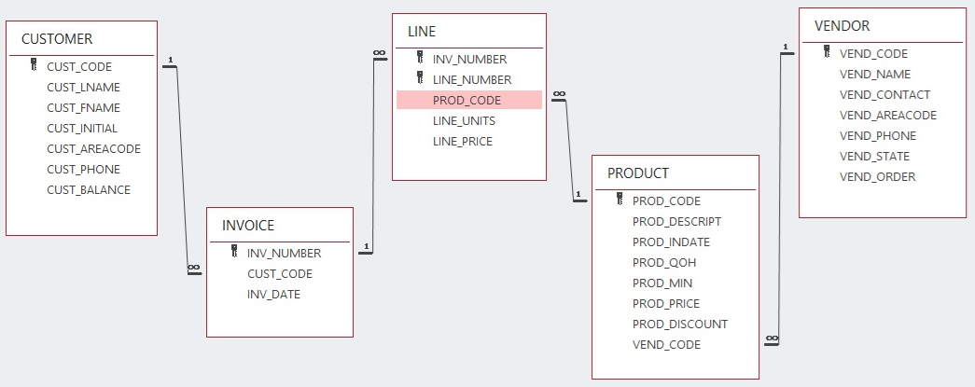
Data: THE DATA IS ALSO AVAILABLE IN A SEPARATE TEXT FILE.
/* VENDOR rows */
21225, 'Bryson, Inc.' , 'Smithson','615','223-3234','TN','Y'
21226,'SuperLoo, Inc.' ,'Flushing','904','215-8995','FL','N'
21231,'D&E Supply' ,'Singh' ,'615','228-3245','TN','Y'
21344,'Gomez Bros.' ,'Ortega' ,'615','889-2546','KY','N'
22567,'Dome Supply' ,'Smith' ,'901','678-1419','GA','N'
23119,'Randsets Ltd.' ,'Anderson','901','678-3998','GA','Y'
24004,'Brackman Bros.' ,'Browning','615','228-1410','TN','N'
24288,'ORDVA, Inc.' ,'Hakford' ,'615','898-1234','TN','Y'
25443,'B&K, Inc.' ,'Smith' ,'904','227-0093','FL','N'
25501,'Damal Supplies' ,'Smythe' ,'615','890-3529','TN','N'
25595,'Rubicon Systems' ,'Orton' ,'904','456-0092','FL','Y'

/* PRODUCT rows */
'11QER/31','Power painter, 15 psi., 3-nozzle' ,'03-NOV-2021', 8, 5,109.99,0.00,25595
'13-Q2/P2','7.25-in. pwr. saw blade' ,'13-DEC-2021', 32, 15, 14.99,0.05,21344
'14-Q1/L3','9.00-in. pwr. saw blade' ,'13-NOV-2021', 18, 12, 17.49,0.00,21344
'1546-QQ2','Hrd. cloth, 1/4-in., 2x50' ,'15-JAN-2022', 15, 8, 39.95,0.00,23119
'1558-QW1','Hrd. cloth, 1/2-in., 3x50' ,'15-JAN-2022', 23, 5, 43.99,0.00,23119
'2232/QTY','B&D jigsaw, 12-in. blade' ,'30-DEC-2021', 8, 5,109.92,0.05,24288
'2232/QWE','B&D jigsaw, 8-in. blade' ,'24-DEC-2021', 6, 5, 99.87,0.05,24288
'2238/QPD','B&D cordless drill, 1/2-in.' ,'20-JAN-2022', 12, 5, 38.95,0.05,25595
'23109-HB','Claw hammer' ,'20-JAN-2022', 23, 10, 9.95,0.10,21225
'23114-AA','Sledge hammer, 12 lb.' ,'02-JAN-2022', 8, 5, 14.40,0.05,NULL
'54778-2T','Rat-tail file, 1/8-in. fine' ,'15-DEC-2021', 43, 20, 4.99,0.00,21344
'89-WRE-Q','Hicut chain saw, 16 in.' ,'07-FEB-2022', 11, 5,256.99,0.05,24288
'PVC23DRT','PVC pipe, 3.5-in., 8-ft' ,'20-FEB-2022',188, 75, 5.87,0.00,NULL
'SM-18277','1.25-in. metal screw, 25' ,'01-MAR-2022',172, 75, 6.99,0.00,21225
'SW-23116','2.5-in. wd. screw, 50' ,'24-FEB-2022',237,100, 8.45,0.00,21231
'WR3/TT3' ,'Steel matting, 4''x8''x1/6", .5" mesh','17-JAN-2022', 18, 5,119.95,0.10,25595

/* CUSTOMER rows */
10010,'Ramas' ,'Alfred','A' ,'615','844-2573',0
10011,'Dunne' ,'Leona' ,'K' ,'713','894-1238',0
10012,'Smith' ,'Kathy' ,'W' ,'615','894-2285',345.86
10013,'Olowski' ,'Paul' ,'F' ,'615','894-2180',536.75
10014,'Orlando' ,'Myron' ,NULL,'615','222-1672',0
10015,'O''Brian','Amy' ,'B' ,'713','442-3381',0
10016,'Brown' ,'James' ,'G' ,'615','297-1228',221.19
10017,'Williams','George',NULL,'615','290-2556',768.93
10018,'Farriss' ,'Anne' ,'G' ,'713','382-7185',216.55
10019,'Smith' ,'Olette','K' ,'615','297-3809',0

/* INVOICE rows */
1001,10014,'16-JAN-2022'
1002,10011,'16-JAN-2022'
1003,10012,'16-JAN-2022'
1004,10011,'17-JAN-2022'
1005,10018,'17-JAN-2022'
1006,10014,'17-JAN-2022'
1007,10015,'17-JAN-2022'
1008,10011,'17-JAN-2022'

/* LINE rows */
1001,1,'13-Q2/P2',1,14.99
1001,2,'23109-HB',1,9.95
1002,1,'54778-2T',2,4.99
1003,1,'2238/QPD',1,38.95
1003,2,'1546-QQ2',1,39.95
1003,3,'13-Q2/P2',5,14.99
1004,1,'54778-2T',3,4.99
1004,2,'23109-HB',2,9.95
1005,1,'PVC23DRT',12,5.87
1006,1,'SM-18277',3,6.99
1006,2,'2232/QTY',1,109.92
1006,3,'23109-HB',1,9.95
1006,4,'89-WRE-Q',1,256.99
1007,1,'13-Q2/P2',2,14.99
1007,2,'54778-2T',1,4.99
1008,1,'PVC23DRT',5,5.87
1008,2,'WR3/TT3',3,119.95
1008,3,'23109-HB',1,9.95

Select query specifications to generate five reports, continue:
Query-1:
List Customer Code, Customer First, Customer Last, Invoice Number, and Total as SUM of the product (Line Number * Line Price) for each Group By (Customer Code, Customer First, Customer Last, Invoice Number).
In the output report, include a summary of the totals as shown in the report sample below.
Query-2:
List Invoice Number, Line Number, Product Code, Product Description, Line Units, Line Price, and the Product of (Line Units times Line Price) for all invoices belonging to the customer with Customer Code = 10011.
In the output report, include a summary of the totals as shown in the report sample below.
Query-3:
List Vendor Code, Vendor Name, Vendor Contact, Vendor Phone, and Vendor State of all Vendors with Vendor AreaCode = 615 OR located in state = TN.

Query-4:
List Product Code, Product Description, Product In Date, Product Quantity On Hand (QOH), Product Minimum for each product in which Product Quantity On Hand is just five items or less higher than the minimum level.
Query-5:
List Product Code, Product Description, Product In Date, Product Quantity On Hand (QOH) for each product not sold yet. Sort the list by Product Description.

Reports are generated from the information provided by the corresponding query. The samples below show how the reports should look when you execute the program. My recommendation is that each report be generated in a separate output file and from a separate method for organizational purposes. Note that the output samples below may not necessarily reflect the data in your database.
Output Report-1:
INVOICE TOTALS PER INVOICE AND CUSTOMER
Customer Customer Customer
Code First Name Last Name Invoice Total
10011 Leona Dunne 1002 4.99
10011 Leona Dunne 1004 24.89
10011 Leona Dunne 1008 275.62
10012 Kathy Smith 1003 163.82
10014 Myron Orlando 1001 34.89
10014 Myron Orlando 1006 1284.64
10015 Amy O'Brian 1007 24.97
10018 Anne Farriss 1005 5.87
TOTALS 1819.69

Output Report-2:
INVOICES BELONGING TO CUSTOMER WITH CODE:10011
INVOICE LINE CODE DESCRIPTION UNITS PRICE TOTAL
1002 1 54778-2T Rat-tail file, 1/8-in. fine 2 4.99 9.98
1004 1 54778-2T Rat-tail file, 1/8-in. fine 3 4.99 14.97
1004 2 23109-HB Claw hammer 2 9.95 19.90
1008 1 PVC23DRT PVC pipe, 3.5-in., 8-ft 5 5.87 29.35
1008 2 WR3/TT3 "Steel matting, 4'x8'x1/6"", .5"" mesh" 3 119.95 359.85
1008 3 23109-HB Claw hammer 1 9.95 9.95
TOTALS 16 155.70 444.00

Output Report-3:
VENDORS LOCATED IN THE STATE OF TENNESSEE OR WITH AREA CODE: 615

VEND CODE VEND NAME VEND CONTACT VEND_PHONE VEND_STATE
21225 Bryson, Inc. Smithson 223-3234 TN
21231 D&E Supply Singh 228-3245 TN
21344 Gomez Bros. Ortega 889-2546 KY
24004 Brackman Bros. Browning 228-1410 TN
24288 ORDVA, Inc. Hakford 898-1234 TN
25501 Damal Supplies Smythe 890-3529 TN

Output Report-4:
PRODUCTS WITH FIVE ITEMS OR LESS HIGHER THAN THEIR MINIMUM LEVEL

PROD_CODE PROD_DESCRIPT PROD_INDATE PROD_QOH PROD_MIN
11QER/31 Power painter, 15 psi., 3-nozzle 03-Nov-11 8 5
2232/QTY B&D jigsaw, 12-in. blade 30-Dec-11 8 5
2232/QWE B&D jigsaw, 8-in. blade 24-Dec-11 6 5
23114-AA Sledge hammer, 12 lb. 02-Jan-12 8 5

Output Report-5:
PRODUCTS IN STOCK WITHOUT A PLACED ORDER

PROD_CODE PROD_DESCRIPT PROD_INDATE PROD_QOH
11QER/31 Power painter, 15 psi., 3-nozzle 03-Nov-11 8
14-Q1/L3 9.00-in. pwr. saw blade 13-Nov-11 18
1558-QW1 Hrd. cloth, 1/2-in., 3x50 15-Jan-12 23
2232/QWE B&D jigsaw, 8-in. blade 24-Dec-11 6
23114-AA Sledge hammer, 12 lb. 02-Jan-12 8
SW-23116 2.5-in. wd. screw, 50 24-Feb-12 237

